**Mobile Robotics**

**Assignment 1**

**Real-Time Navigation of Mecanum Wheel based Mobile Robot**

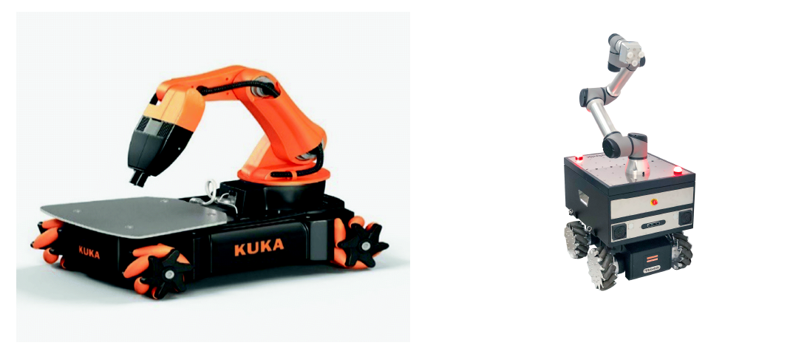

Mecanum wheels are special types of wheels used in robotics and vehicles to enable omnidirectional movement. They are designed with a series of rollers mounted at an angle around the circumference of the wheel. These rollers allow the wheel to move not just forward and backward like traditional wheels but also sideways and diagonally.

The key feature of mecanum wheels is their ability to independently control each wheel's rotation direction and speed. By varying the speeds and directions of multiple mecanum wheels on a vehicle, you can achieve complex movements like strafing, rotating in place, and moving diagonally.

Mecanum wheels are commonly used in robotic platforms, especially those designed for agile and precise movement in tight spaces. They require specific control algorithms to coordinate the movement of each wheel effectively, but they offer great versatility in terms of maneuverability compared to standard wheels.

**Kinematics**

In Fig. 1 a mobile robot model with mecanum wheel is given with coordinate system attached at the center of the wheel hub the unit axis is denoted by (𝑋𝑤, 𝑌𝑤). The robot position and orientation is denoted as 𝑥𝑟, 𝑦𝑟, 𝜃𝑟. The linear velocity of robot is (𝑣𝑥𝑟, 𝑣𝑦𝑟) and 𝜔𝑟 is its angular velocity, while 𝜔𝑚𝑖 is angular velocity of 𝑖𝑡ℎ wheel and 𝑣𝑚𝑖 donated the linear wheel velocity. The angle between the free sliding roller axis and the wheel hub axis can be either positive 45◦ or negative 45◦ depending on whether the wheel is left or right.

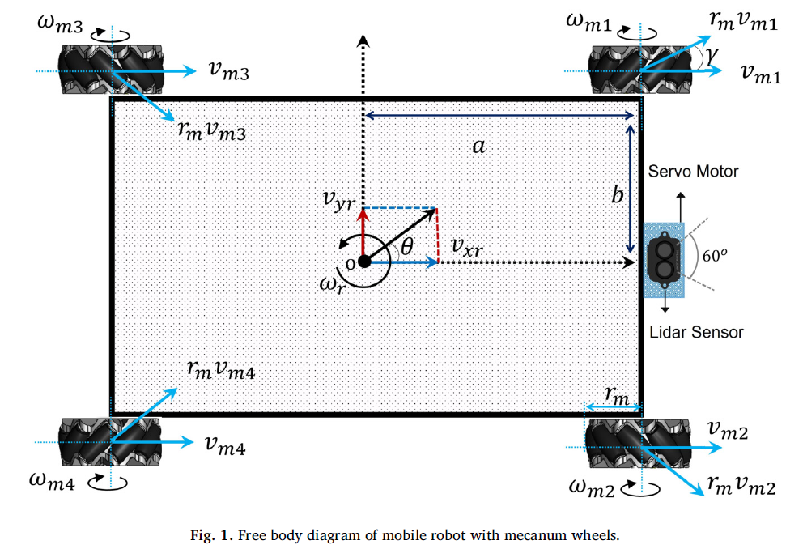

For wheel 1 and wheel 4, 𝛾 =-45◦ while for wheel 2 and wheel 3, 𝛾 = 45◦ Hence, the inverse transformation which transform mobile robot task space velocity to its joint velocity as follows

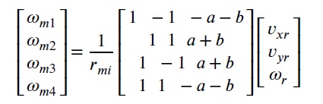

The following forward kinematic equation can be obtained by taking inverse matrix.

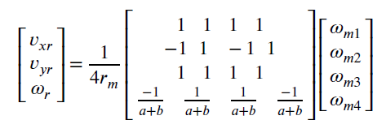

Based on these velocities mobile, robot moves in any direction. The direction of mobile robot’s motion based on the mecanum wheel motion is shown in Fig. 2.

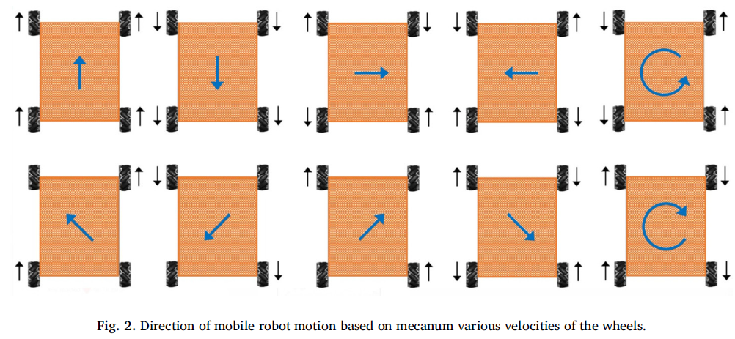

**Reference**

[1] *M.U. Shafiq, A. Imran, S. Maznoor et al. Real-time navigation of mecanum wheel-based mobile robot in a dynamic environment, Heliyon 10 (2024) e26829*